Vacation Unit
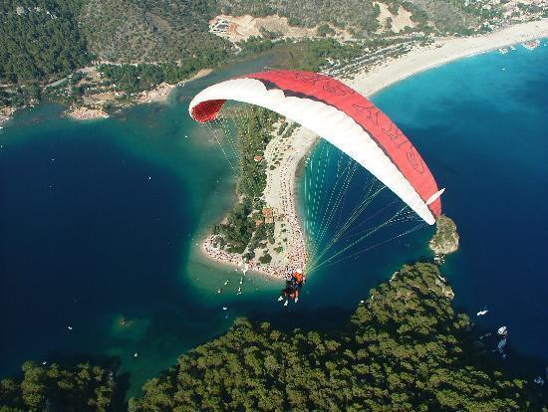

By: Natasha Zeng
Wheaton College

Vacation Lesson 1: Where did you go on vacation? (Writing)
Objectives:
- Students will demonstrate understanding of basic conversations about vacation.
- Students will learn how to use and write these vocabulary properly: anyone, anywhere, wonderful, quite a few, most, something, nothing, everyone, of course, myself, yourself .

Materials:
Vocabulary lists
Fill-in-the-blank worksheets
Writing utensils
Vacation-related images for matching activity
Language Points handout
Video: Last Weekend (1’14’’)
Markers

Warm-up & Presentation (8 - 10 minutes):
Ask students “What did you do in your summer vacation?” to warm up the class, and show pictures of places of interests of the world by PowerPoint.
Here is an example:
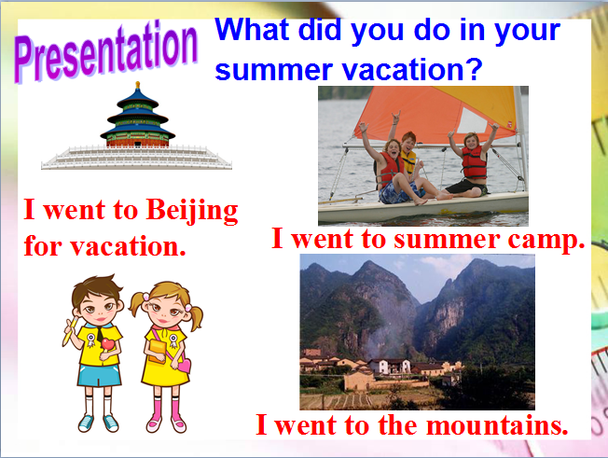

2) Read Beijing Tour guide article together in class:
http://www.travelchinaguide.com/cityguides/beijing.htm

“Being capital of the People's Republic of China, it is the nation's political, economic, cultural, educational and international trade and communication center. Located in northern China, close to the port city of Tianjin and partially surrounded by Hebei Province, it also serves as the most important transportation hub and port of entry.
As one of the six ancient cities in China, it has been the heart and soul of politics and society throughout its long history and consequently there is an unparalleled wealth of discovery to delight and intrigue travelers as they explore the city's ancient past and exciting modern development. Now it has become one of the most popular tourist destinations in the world, with about 140 million Chinese tourists and 4.4 million international visitors in a year.”

After reading the article, students need to write down the answers for these questions:
- Where is Beijing?
- Beijing is a _________________________ center.
- How many ancient cities in China?
- How many international tourists in Beijing yearly?

Activity 1 (10 minutes):
Matching activity
–Pass out an handout like the following.

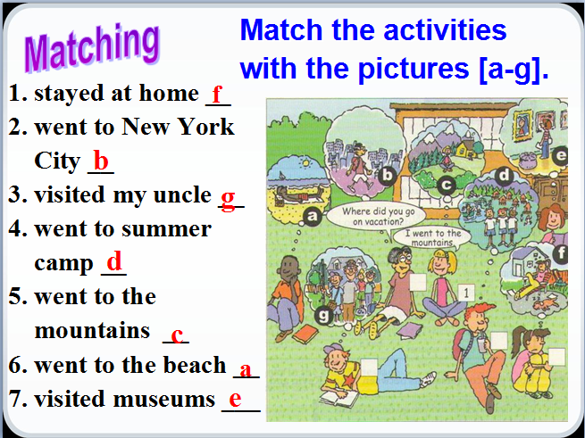

-Let students read the expressions on the pictures and the teacher will read it again in class.
-The teacher will ask the class:
What can you see?
Then say, “Each picture shows something a person did in the past.”
-Name each activity and ask students to repeat:
- stayed at home,
- went to mountains,
- went to New York City,
- went to the beach,
- visited my uncle,
- visited museums,
- went to summer camp
-Ask students to match each phrase with one of the pictures next to the name of the
activity
-Check out the answers with students and read it together with the students.
Answers: 1. f 2. b 3. g 4. e 5. c 6. a 7. d

Assessment: Teacher will check the answers with students to determine comprehension of the task.

Language points (15 minutes):
Did you buy anything special?
-Explain these pronouns:
anything -- anyone
Something-- someone
Nothing -- no one
Everything -- everyone (anybody, somebody, nobody and everybody)
e.g. I can see someone new in your group.
There’s nothing interesting in the news today.
2. Did you go anywhere interesting?
- Use of “Anywhere” and “somewhere”
e.g. I can’t find my keys anywhere.
3. We took quite a few photos there.
a few =some
quite a few =many
e.g. A few girls are playing volleyball.
There are quite a few birds in the forest.

-Pull out a piece of paper and pass it along to students. Then have a whole class write a story using these pronouns. Each student will write one sentence and pass it along to the next one. At the end, the teacher and student will read this story together.

Activity 2 (10 minutes): Pair work
1. Let two students read the conversation between Grace, Kevin and Julie.
2. Let students work in pairs and try to role-play the conversation.
3. Ask some pairs to act out their conversations.

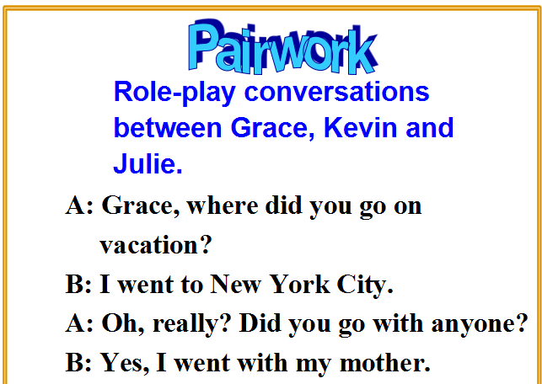

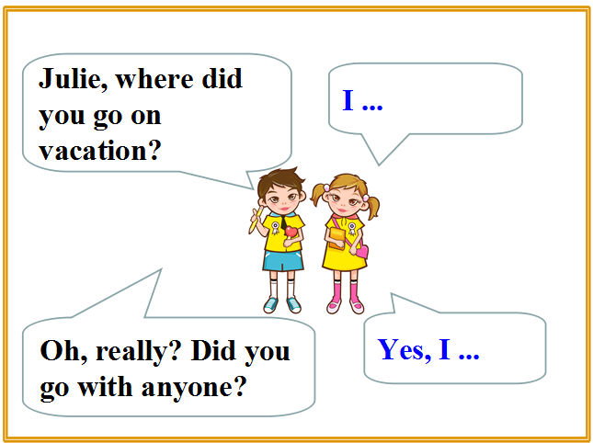
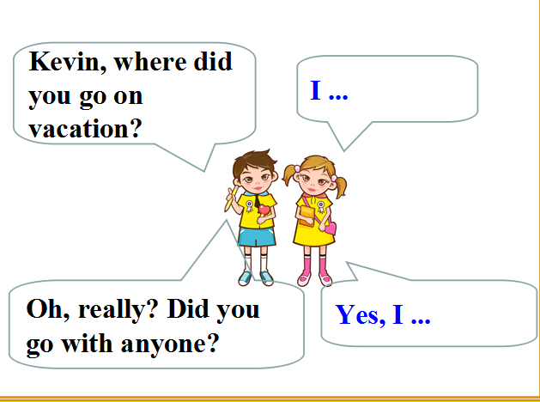

4. Students will write down their daligue in their group paper and the teacher will collect and grade them after class.

Assessment: Teacher will monitor participation and learner understanding, making sure that each student responds at least once.

Closure (5 minutes):
-Quick review of today’s material. Does anyone have any questions?
-Give a quick overview of tomorrow’s lesson: students will learn about how to use past tense in writing.
-Homework:
Ask your friend where did they go for vacation and write down the dialogue.
A: Where did you go…？
B: I went to…
A: Did you see…
B: Yes, I did. / No, I didn’t.

Vacation Lesson 2: Grammar Focus and Past Tense

Objectives:
- Students will be able to use anyone, someone, everyone, something, anything, nothing correctly in their writing activities.
- Students will learn how to use past tense in their writings.

Materials:
-Printed dialogues and letters
-Worksheets
-Writing utensils

Warm-up & Presentation (5 minutes):
Free talk:
Ask students: Where did you go on vacation?
Students try to answer the questions.
Review the usage of pronouns

Activity 1 (15 minutes): Fill-in-the-blank activity
Students need to fill in the blanks with the words in the box and practice the conversation using these words in the box.

Anyone, something, anything, everything, nothing

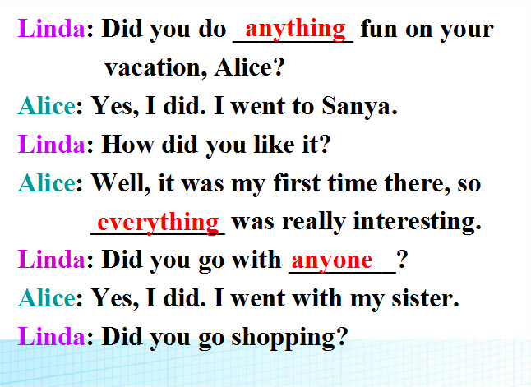

Assessment: Teacher will walk around class and take notes while observing students as they practice their conversations, offering pronunciation assistance and answering any questions.

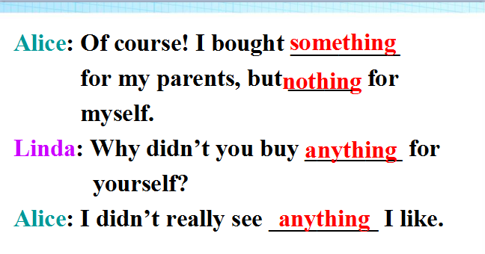
Language Points (15 minutes):
How did you like it?
Explain: How ... sb. like ...?
What ... sb. think of ...?
E.g.: How do you like the TV show? =What do you think of the TV show?
Seem
◆seem+(to be)+adj.
The movie seems (to be) interesting.
◆seem to do sth.
The boy seems to know nothing about it.
◆It seems that ...
It seems that Mr. Zhang is at home.
Activity 2 (25 minutes): Group Activity
1)Ask your group questions about their vacation. Then tell the class your results.
2) Fill in the blanks according to the answers.
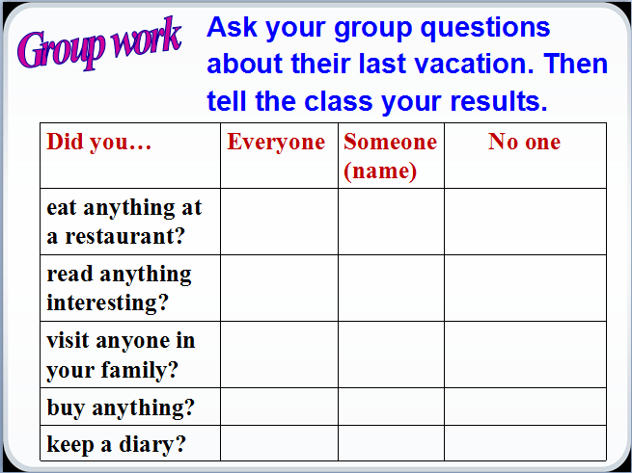

3) Read a short article about different kinds of report in class with students.
Retrieved from: http://www.businesstrainingcollege.com/business/report-writing.htm

“What kinds of Report are there?
There are lots of different kinds of report, such as:
routine – occurring on a regular basis
special – those that are required to cover a specific subject or task
technical – these cover complex technical issues
And, which report you choose to complete will be determined by the subject you are writing about. All reports should be presented in a professional manner making the information easy to read and absorb.
As you can see, reports are useful in all work environments, but the ones we are most concerned with are those that are used for business.”

4) After reading it, ask the students to define what types of report they are going to write and have them write the report in each group. Then let one student read the report to the class. The teacher will present this model below during the activity and teach students this report needs to be done in past tense.
For example: eat -- ate
read -- read
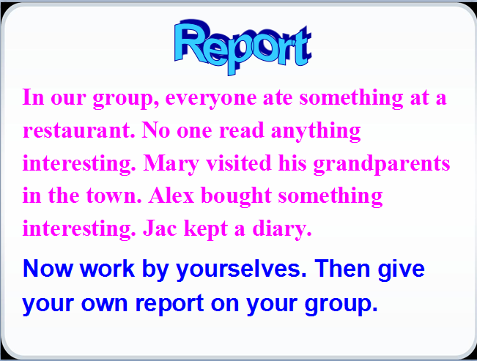

Assessment: Teacher will walk around class and take notes while observing students as they complete their charts, answering any questions. Teacher will give candies to the best group presenter.

Activity 3 (10 minutes): Dear Bill Letter
-Fill in the blanks in the e-mail message with the words in the box.
anything, everything, nothing, everyone, no one

Dear Bill,
How was your vacation? Did you do ________ interesting? Did _______ in the family go with you? I went to a friend’s farm in the countryside with my family. __________ was great.
We fed some hens and saw some baby pigs. They were so cute! The only problem was that there was _______ much to do in the evening but read. Still ______ seemed to be bored. Bye for now!
Mark

Answer: Anything;Anyone;Everything;Nothing;No one.

Assessment: Teacher will walk around and check how students are doing. Teacher will check the answer as soon as all students are finished.

Closure (3-5 minutes):
-Teacher will review what students learned today, then ask if there are any more questions, especially regarding any words or phrases in the dialogues activity.

-Homework:
1)Finish this exercise (Give handout to students)
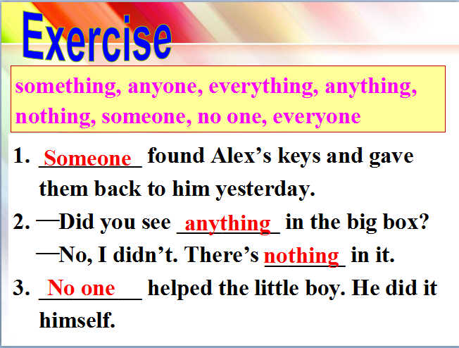
2) Have students write freely for 5 minutes about what they did today using past tense and collect these journals tomorrow.

Vacation Lesson 3: How to use past tense to ask questions?
Objectives:
- Students will be able to demonstrate understanding of how to answer and communicate in
① Where did…?
② What did…?
③ How was…？ / How were…?
④ Did she/he…?
And use these answers to write a short essay.

Materials:
-Worksheets
-Handout
-Writing utensils

Warm-up/Presentation (5 - 10 minutes):
1. Daily greeting

2. Check their homework. Let some students report where did they go on vacation.

3. Reflexive prounoun
Reflexive pronoun
myself | ourselves
yourself | yourselves
himself | themselves
herself
itself

Vocabulary (15 minutes):
-Explain what these words or phrases mean and how they are used in a past tense sentence.
decide, try, paragliding, feel like, bird, bicycle, building, trader, wonder, difference, top, wait,umbrella, wet, because of, below, enough, hungry

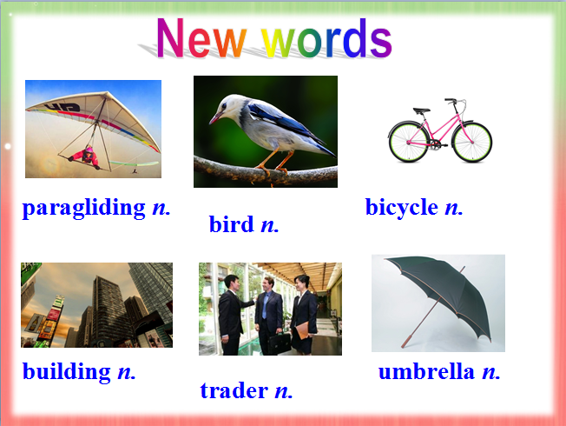

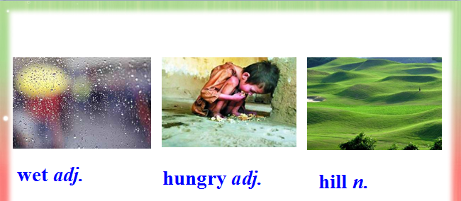

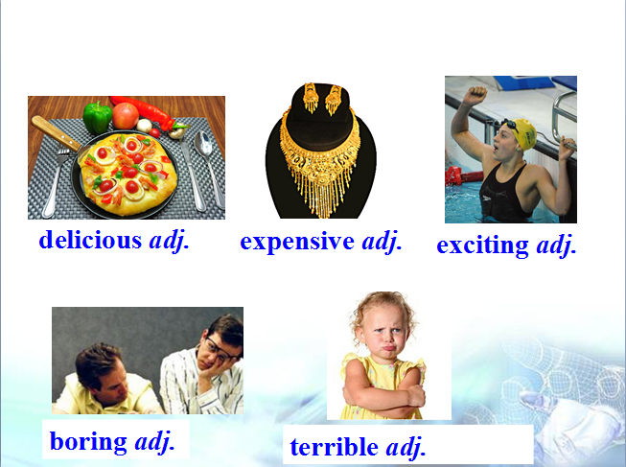

-After that, have students choose 3 new words and write down a five-sentence essay. Then collect and grade them after class.

Activity 1 (15 minutes):
Matching and putting words back in order
-Match the words with the pictures below.
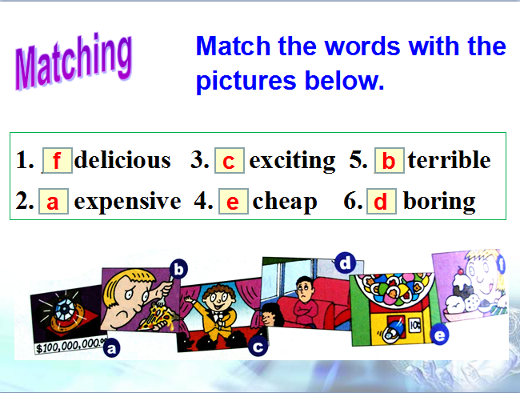

-Look at the words again. Write :) words on the left. Write :( words on the right.
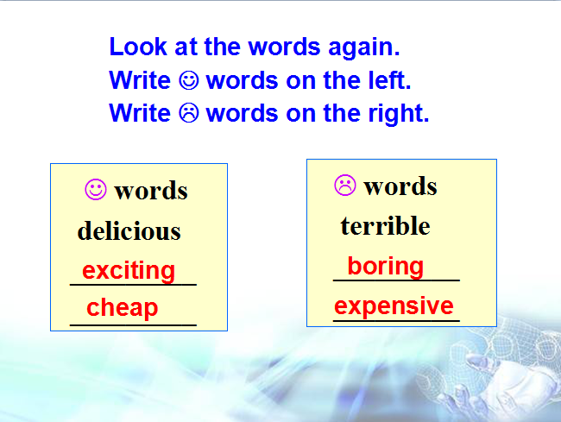

Assessment: Teacher will monitor student responses to questions as means of assessing their listening comprehension.

Activity 2 (20 minutes): – Discussion: Jane’s Diary
-Lead in: Discuss the questions with your partner.
1.What do people usually do on vacation?
They usually __________________

2.What activities do you find enjoyable?
Going fishing. ____________________
-Jane’s Diary
1) Read Jane’s Dairy together in class with the original text, and then remove the original text and make it as a fill in the blanks format. Have the students not to look at the original text to fill out the information.
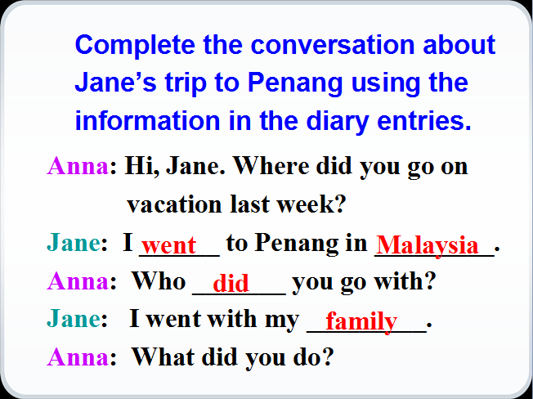

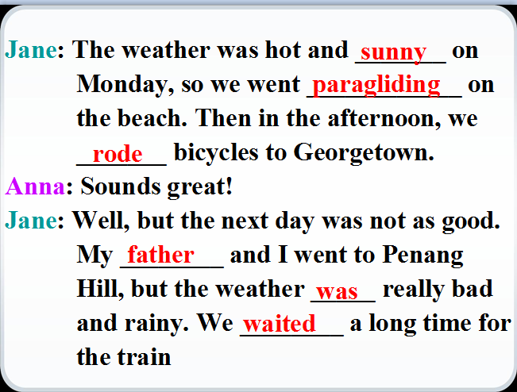

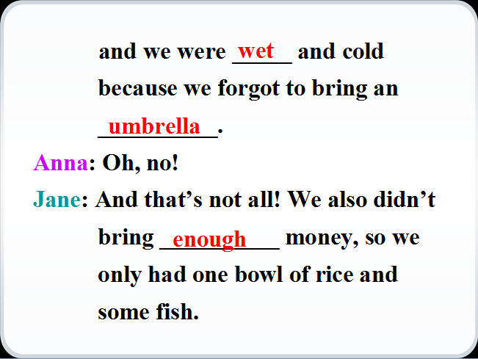

-Read the original Jane’s diary entries again and fill out the chart.
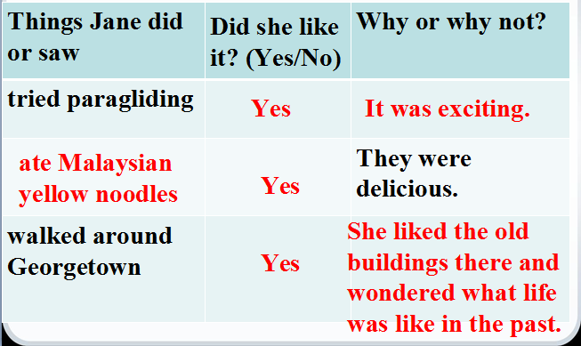

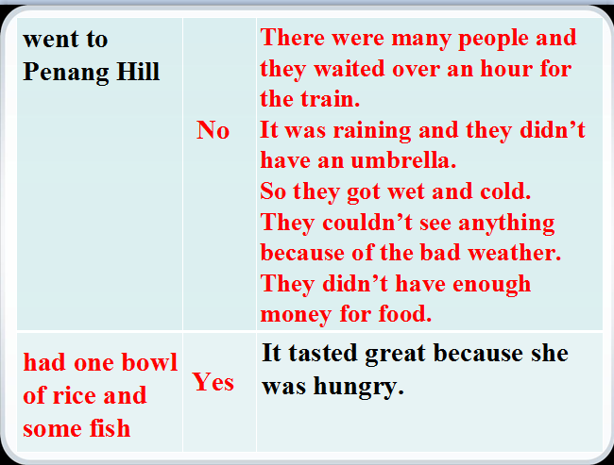

Assessment: Teacher will go around and observe students as they complete the letter, answering any questions students may have.

Closure (5 minutes):
-Ask if students have any other questions.
-Homework: Choose the right word for the sentence.
1. I feel like ______ (going/go) to Hong Kong for vacation next summer vacation.
2. He’s not going to buy that car _______ (because /because of) it’s too expensive.
3. The train was late _________ (because/ because of) the heavy frog.
4. Her coat reaches _____ (below/ under) her knee.
5. The boy is _________ (enough old/ old enough) to get dressed himself.

Vacation Lesson 4: My Vacation Experience
Objectives:
- Students will be able to demonstrate understanding of how to read about their vacation experience
- Students will be able to use irregular past tense of various verbs in their writing.
Materials:
-Worksheets
-Handout
-Writing utensils

Warm-up/Presentation (10 minutes):
1. Show some pictures of the some places of interest in China. Give students names of them.
e.g. the Great Wall, Summer Palace, Tian’anmen Square, a Beijing Hutong
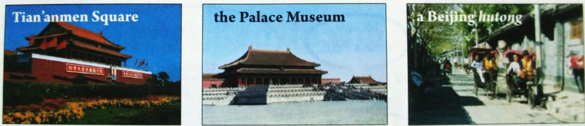

Let students discuss what they can do, eat, buy… in those places.

Complete an diary entry based on the information above.

Complete the diary entry about a trip to one of these places. Use the words and phrases in the box to help you.
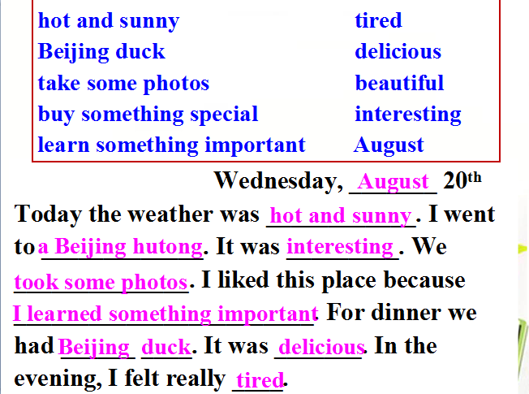

Activity 1 (20 minutes): Write a travel diary like Jane’s diary, using past tense. This diary should contain at least five sentences and a usage of one irregular past tense of a verb. (Students can use their notes from the past.)
For example: go - went

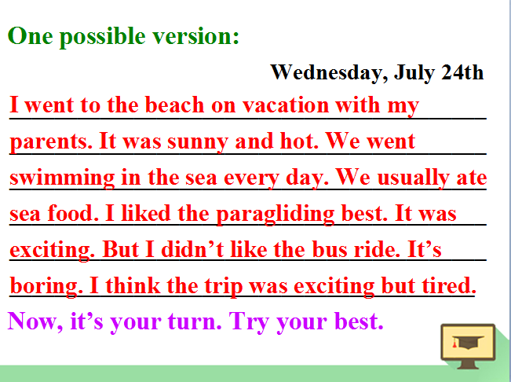

Assessment: Teacher will collect these diaries and grade them afterwards individually.

Activity 2(15 minutes):Complete the passage with the correct forms of the verbs in the brackets.
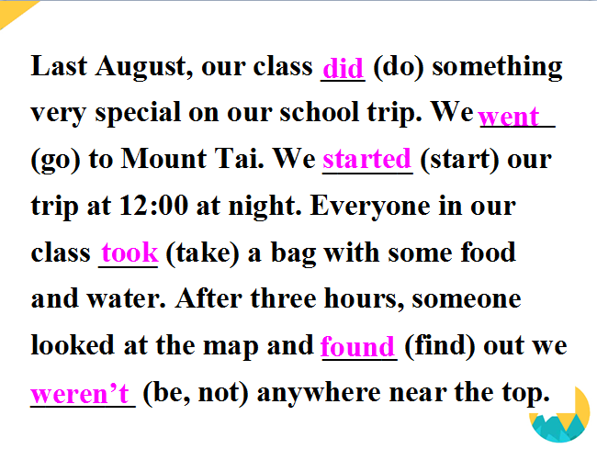

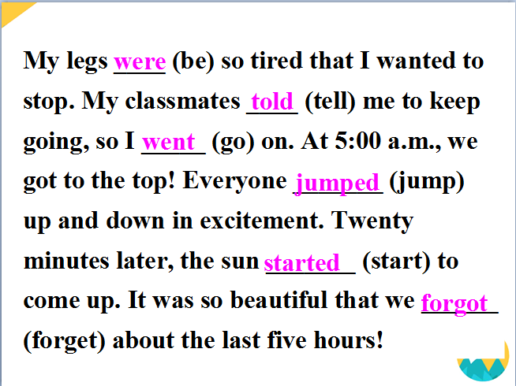

Assessment: Teacher will walk around class and take notes while observing students as they complete this exercise. Teacher will check out answers as soon as the students finish up this passage.

Closure (5 minutes):
-Ask if students have any other questions.
-Homework: Using the right form of verb in these following sentences.
1.My mother ______ (buy) a new schoolbag for me yesterday.
2.When _____ you _____ (start) to learn English?
3.My aunt ______ (take) us to dinner at a restaurant but the food _______ (is) not good at all.
4.When I _______ (am) in America, I _______ (make) a lot of new friends.
5.They _______ (have) a great sale last weekend.

Vacation Lesson 5: How often do you go on vacation?
Objectives:
- Students will be able to use the adverbs of frequency such as always, usual, often and so forth in their reading and writing exercises.
- Students can comprehend past tense article.
① —What does he do on vacations? —He usually watches TV.
② —How often do you watch TV? —I watch TV every day.
③ —Does he ever go shopping while he’s on vacation?
—No, he never go shopping.

Materials:
-Worksheets
-Handouts
-Writing utensils

Warm-up/Presentation (5 minutes):
-Ask students what were their last vacation activities.
Did you enjoy your last vacation?
Was it interesting?
What did your parents do on their last vacation?
-Students should give “I usually …… on vacation” as answers.

Activity 1 (15 minutes): Read and choose the best answer for this diary.
My name is Eric. Last July, I went to Walt Disney World in Orlando, Florida. It was a wonderful trip because I spent time with my family. I went there with my dad, mom, brother and sister. We had lots of fun there.
We took my dad’s new car to Florida. It was a long trip but we enjoyed ourselves on the way.
We went to a dinner show — Jolly Holiday. It has funny characters and lots of singing. We enjoyed it.
I went on rides with my dad, brother and sister. We went on Splash Mountain. We went through a tunnel. We saw different Disney characters. My mom took photos of me with different Disney characters. We saw Cinderella at the Magic Kingdom. She gave a show with her friends. At the Beach Club Resort, my family saw Chip and Dale. They walked around to meet everyone.

When did Eric take a trip to Walt Disney World last year?
A. In June. B. In July. C. In August. D. In October.
How many people went with Eric?
A. Two. B. Three. C. Four. D. Five.
How did Eric get to Florida?
A. By car. B. By bus. C. By train. D. By plane.
Where did Eric see Cinderella?
A. At a dinner show.
B. On Splash Mountain.
C. At the Magic Kingdom.
D. At the Beach Club Resort.
Which of the following is TRUE?
A. Cinderella gave a show at Jolly Holiday.
B. Eric went on rides with his dad and mom.
C. Chip and Dale walked around to meet people.
D. Eric’s dad took photos of him with Disney characters.

Answer: BCACC

Assessment: Teacher will monitor student responses to questions as means of assessing their reading and writing comprehension.

Activity 2(20 minutes): – Pair work
-Practice conversation with partners
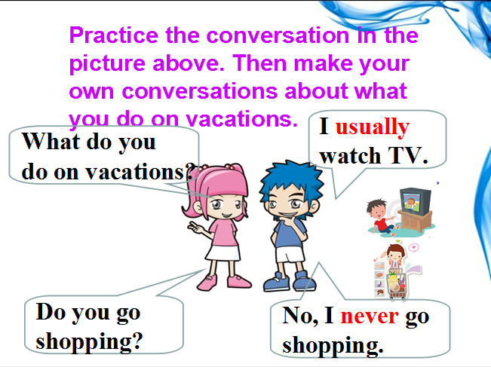

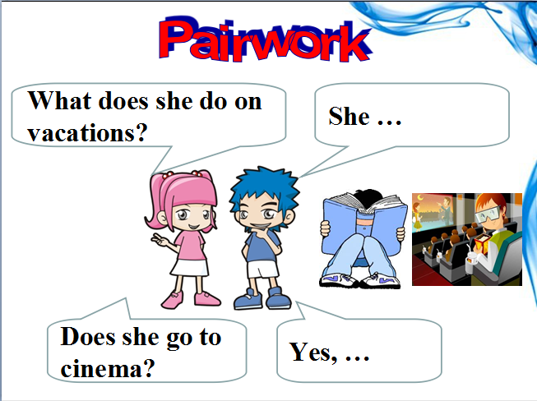

-Game: Who can use the right adverbs?

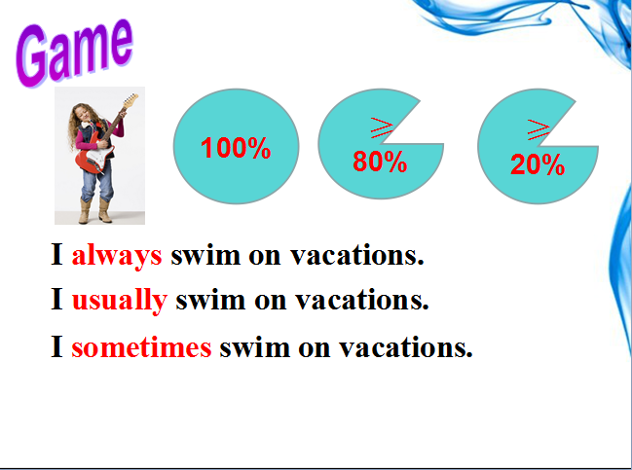

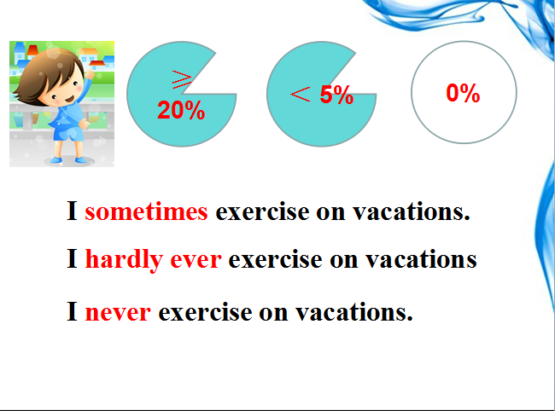
--Give a chart to explain adverbs:

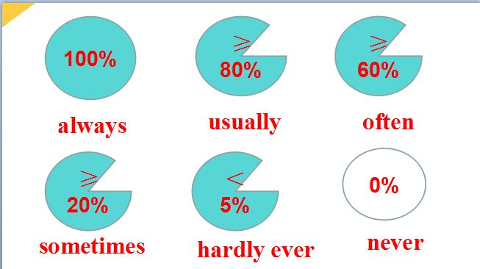

Assessment: Teacher will walk around class and take notes while observing students as they complete their pair work. Teacher will determine who wins the adverb game and give the winner chocolate as rewards.

Closure (5 minutes):
-Ask if students have any other questions.
-Homework:
Look up the dictionary and find out the difference between “hardly” and “hardly ever”
Peter is hardly ever late.
He can hardly speak English.

Vacation Lesson 6: What does he/she do on vacations?
Objectives:
- Students will be able to tell the difference between simple past tense and simple present tense and be able to use it in their reading.
- Students will be able to use adverbs such as hardly ever, hardly, sometimes in their reading and writings.

Materials:
-Worksheets
-Handouts
-Writing utensils
-Language Points
-Survey sheet

Warm-up (5-10 minutes):
-Do a survey with your partner.

What does he/she do on vacations?
Name | Activity | How often?
Bob
Jordan
Jared
Linda

-Report to the whole class about your survey
E.g.: Bob usually goes shopping.
Linda hardly ever watches movies.

Activity 1 (25 minutes): Choose your vacation breakfast!
-Match the words with the pictures.
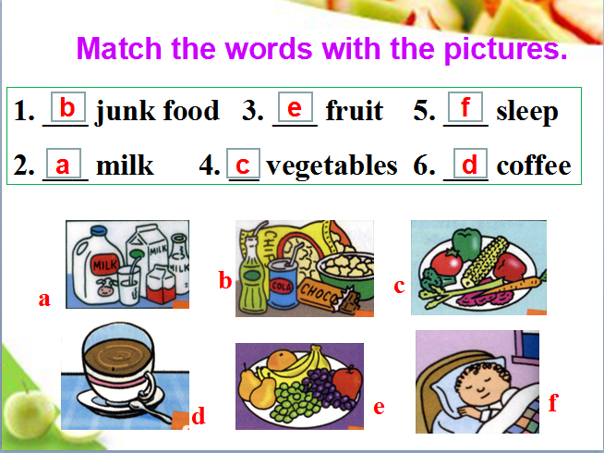

-Find out which is a healthy vacation breakfast and which is an unhealthy vacation breakfast.
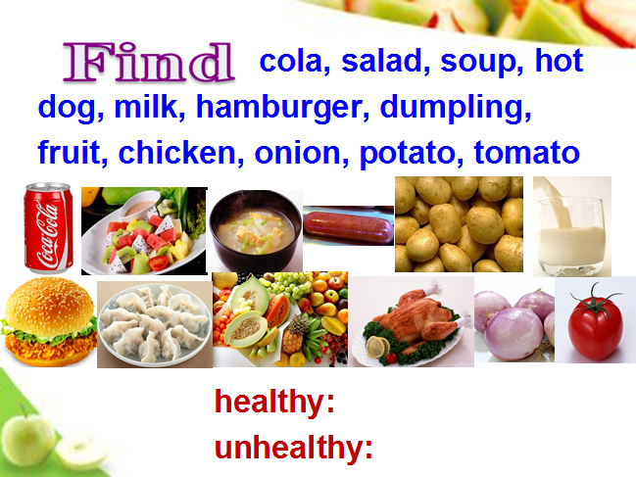

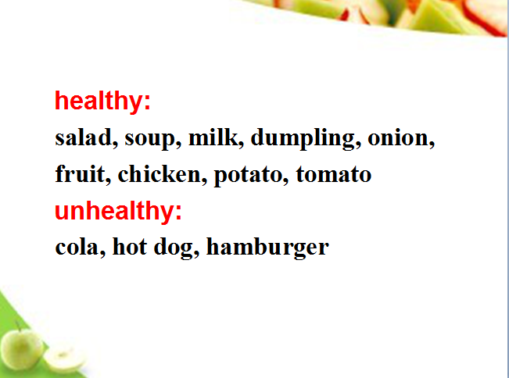

-Read this article for 5 mins and then finish the questions.

The food in Britain is very different from our Chinese food.For instance (例如),they eat a lot of potatoes.They like to eat them every day.They eat bread for breakfast and usually for one other meal. They eat their bread with butter, maybe cheese or jam ,things we don't eat much in China.Cheese and butter are made from milk.They drink a lot of milk,too.They drink the milk cold or hot,and they put it in their tea.They put sugar in their tea,as well.They are the world's biggest tea drinkers.They like Chinese tea,but they drink mostly strong black tea from India and Sri Lanka .They don't eat much rice.For their main meal they like meat or fish with potatoes and one or two vegetables.They serve all these together.After the main meal they always have something sweet.They call this dessert. They don't have Jiaozi in Britain.

Now answer these following questions:
- 1.People eat many ____ in Britain.
- 2.They eat ____ with butter.
- 3. They drink ___ tea.
- 4. After the main meal they always ____.
- 5. People don’t have jiaozi ____.
Answer: Beef; breakfast with; black; have something sweet; Britain.

Assessment: Teacher will monitor answers to get an idea of student comprehension. Get as many students as possible to participate verbally.

Language Points& Vocabulary (10 minutes):
-Be good for
e.g. Milk is good for our health.
Be bad for
e.g. Hot dog is bad for our health.

-Although many students like to watch sports, game shows are the most popular.
e.g. We went fishing although it was cold.
Although he left home early, but he was late. (×)
Although he left home early, he was late. (√)

-Explain these new words:
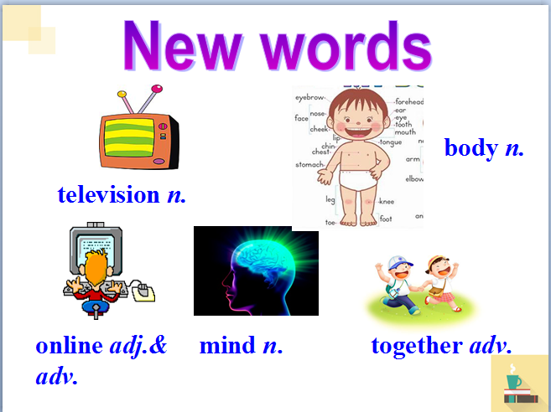

Activity 2 (15 minutes): Good habits VS Bad habits: Choose the right person for your vacation!
You just booked a vacation getaway. However, your school decided to have a field trip on the same day. So you have to choose an candidate to go on a vacation with your family. Who would you choose?

-Here is an article about one particular candidate and write down the pros and cons on why do you want to choose her. (Her habits, lifestyle and etc.)

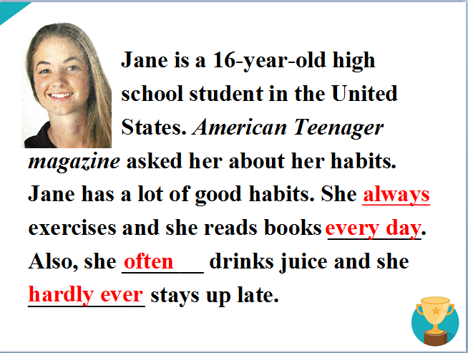

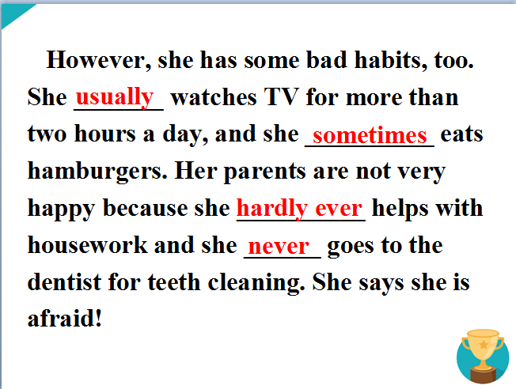

Assessment: Teacher will walk around class and take notes while observing students as they complete their writing materials. Teacher will also grade these articles individually afterwards.

Closure (3-5 minutes):
-Do a quick review of the day’s lesson.
-Homework:
Write a report about your good and bad habits, and how these habits influence your vacation plans. Say how often you do things. The report should contain more than five sentences.

Vacation Lesson 7: Who do you meet on vacation?
Objectives:
1)Students will demonstrate ability to use these words: outgoing, better, loudly, quietly, hard-working, competition, fantastic, which, clearly, win in their writing and reading.
2)Students will be able to compare and contrast pros and cons of two people in their group work.

Materials:
-Worksheets
-Handouts
-Writing utensils

Warm-up (5-8 minutes):
-Ask students to write down as many adj. about people they met on vacation as possible.
-Check the adj. that students write and we can group them into some pairs.
tall --- short; thin --- heavy, long hair --- short hair, calm --- wild
-Give Students an example by comparing Old Henry and Santa Claus.
e.g. Santa Claus is older than Henry. Henry is taller than Santa Claus.
Henry is younger than Santa Claus. Santa Claus is younger than Henry.

Activity 1 (15-20 minutes):
-Part 1: Write the opposite words according to the pictures.
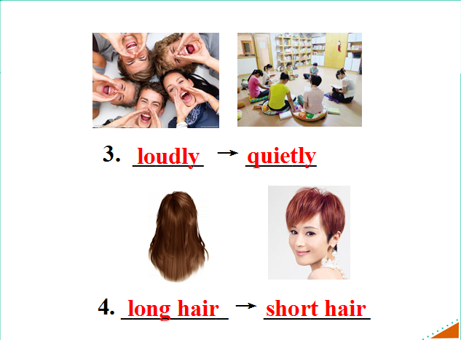
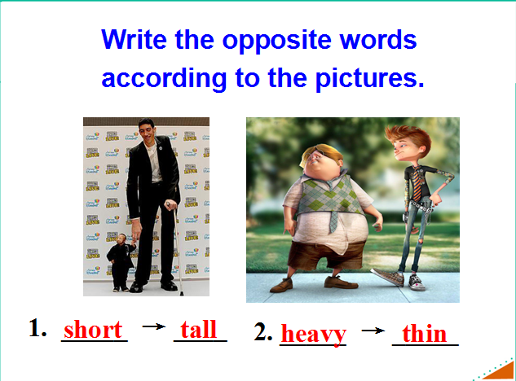

-Part 2 Game:
Ask students to compare with their partners and find out the differences.
e.g. She is heavier than me.
I am more outgoing than her.
She gets up earlier than me.
I run faster than her.

Assessment: Teacher will monitor how students answer – if they understand the assignment, if they know where to look for the information they need, and how well they can communicate.

Activity 2 (15 minutes): Pair Work
-Practice the conversation then make conversations about the other twins.
A: That’s Tara, isn’t it?
B: No, it isn’t. It’s Tina. Tina is taller than Tara. And she also sings more loudly than Tara.

-Listen. Are the words in the box used with –(i)er or more? Complete the chart.
Funny | (run) fast
Friendly | (jump) high
Outgoing | (work) hard
Hard-working | (get up) early
Smart
Lazy

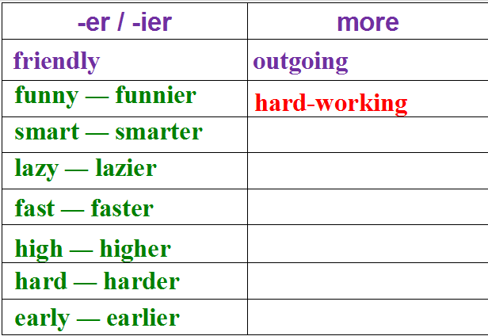

--Write about the things that are the same and different about you while you are on and not on vacations. Use the vocabularies from the previous listening exercise.
For example, the teacher can write, “I run much faster when I am on my vacation because I want to look good on beaches.” And then students can use the model to phrase it.

Assessment: Teacher will walk around classroom as students work on the chart. If necessary, teacher will read the words again for understanding.

Closure (3-5 minutes):
-Review what was learned today.
-Ask if there’s any questions.

Vacation Lesson 8: Who do you meet on vacation? (Grammar Focus)
Objectives:
Students will be able to demonstrate ability to compare and contrast two things together in oral and written English.
2)Students will be able to learn from each others and work together in a team though role play activities.

Materials:
-Worksheets
-Handouts
-Writing utensils

Warm-up (10 minutes): Role play
1. Read the conversation first and try to match the people with the right things.
a.sang better
Nelly

Lisa

b.with shorter hair
c.practice more and really wanted to win
d.sang more clearly
e.danced better

2. Let students read the conversations after the teacher.

3. Let students practice the conversation and then write down a similar conversation.
4. Then let some groups act out their conversations in front of the class and the teacher will collect and grade their work after class.

Language points (5 minutes):

A + be + adj (a comparative form) + than + B
e.g. I’m more outgoing than you.
A + be + as adj. + as + B
e.g. Jack is as funny as Mike.

Activity 1 (15 minutes): Put sentences back in order
-Use the words to write questions and answers.
1. Julie / tall / you
Q: Is Julie as tall as you?
A: No, she isn’t. She’s _____ than me.

2. Jack / run / fast / Sam
Q: ____________________________
A: No, he doesn’t. He runs _____ than Sam.

3. your cousin / outgoing / you
Q: _______________________________
A: No, she isn’t. She is ______________ than me.

4. Paul / funny / Carol
Q: _______________________
A: No, he isn’t. He is _________ than Carol.

Assessment: Teacher will monitor how students answer – if they understand the assignment, and if they understand when to ask questions if needed.

Activity 2 (15-20 minutes): Past VS Present
-Think of yourself two years ago. Write about how you are different now.
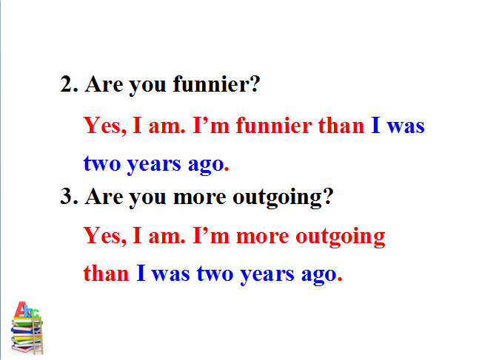
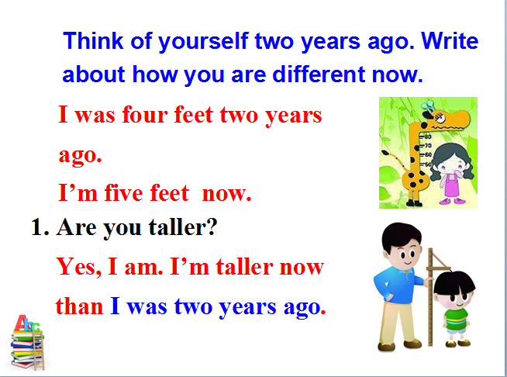

-Survey: Compare your parents. Check (√) who is smarter, funnier, etc. in the chart. Then ask your partner about his /her parents.

A: Who is smarter, your mother or your father?

B: I think my mother is smarter than my father.
 | Mother | Father
smart
funny
work hard
outgoing
friendly
sing well

-After doing the survey, students need to write down at least five sentences by using the information they’ve collected. Exchange their work with their partner and have them self-correct their mistakes.

Assessment: Teacher will walk around classroom as students work on survey. Teacher will choose one group to present and give them candies afterwards.

Closure (3-5 minutes):
-Ask if they have any questions.
-Homework:
Fill in the blanks.
1. My hair is ______ (long) than my sister’s.
2. I am _____ (tall) than you.
3. She is _____ ________ (outgoing) than me.
Answer: longer; taller; more outgoing

Vacation Lesson 9: Roman Holiday

Objectives:
- Students will be able to use these words: theater, comfortable, seat, screen, close, ticket, worst, cheaply, DJ, choose, carefully, reporter, so far, fresh, comfortably in their reading and writings.
- Students will be able to use these sentences:
① It has the biggest screens.
② It’s the most popular.
③ Which is the best clothes store?
④ You can buy clothes the most cheaply there.
⑤ They play the most boring songs.

Materials:
-Worksheets
-Handouts
-Writing utensils
-YouTube Clip: https://www.youtube.com/watch?v=9GzCG6lpFUw (Roman Holiday Trailer)

Warm-up (5 minutes):
-Ask if any students have watched Roman Holiday before; If so, who’s their favorite character.
-Play Roman Holiday Trailer (2’20)
https://www.youtube.com/watch?v=9GzCG6lpFUw

Activity 1 (20 minutes): Choose your favorite holiday movie theater!
Do you like watching movies? Most people love to go to catch a movie on vacation -- whether it’s at the hotel or go to a movie theater. Here are three movie theaters. Look at some information about them and choose the one you suggest I go to on vacation.
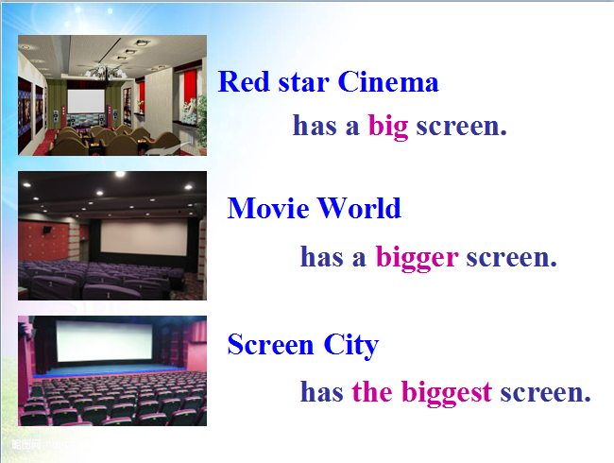
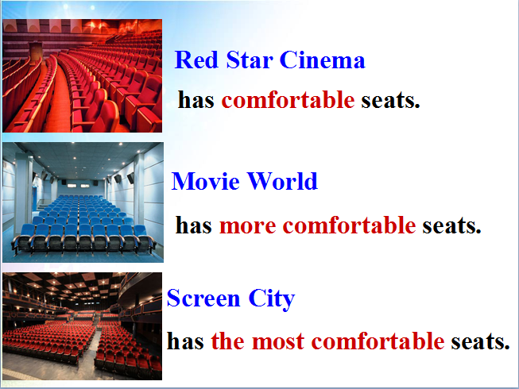

-There are some other factors to affect your choice. Some are important to you and
some are not important.
How do you choose which movie theater to go to? Write the things in the box under “Important” or “Not Important”.

comfortable seats big screens
best sound cheap new movies
close to home buy tickets quickly popular
Important | Not Important

Assessment: Teacher will monitor responses to video, trying to get as many different students as possible to vocally participate. Teacher will then collect worksheets as well.

Activity 2 (20 minutes): Green City Survey
While on vacation, we often want to buy cheap but good clothes at the clothes stores, right? And we can get to know a city through their radio station. A reporter is interviewing a boy about the best clothes store and the best radio station in Green City.
-Reading to a reporter interviewing a boy. Circle the boy’s answers.
Green City Survey

1.Which is the best clothes store?
a. Miller’s b. Blue Moon c. Dream Clothes
2. Which is the best radio station?
a. 970 AM b. 97.9 FM c. 107.9 FM
Answer:AC

-Write the correct store or radio station next to each statement.
Miller’s Blue Moon Dream Clothes carefully.
_________ It’s the most popular.eam Clothes

__
__________ It’s the most expensive.
____________ It has the best clothes.
____________ It’s the worst store.
____________ You can buy clothes the most cheaply there.

Answer: Blue Moon; Miller’s; Dream Clothes; Miller’s
970 AM 97.9 FM 107.9 FM
_________ It’s the most popular.eam Clothes

_________ It has the worst music.
_________ They play the most boring songs.
_________ The DJs choose songs the most carefully.
_________ It’s the most popular.

Answer: 970 AM; 97.9FM; 107.9 FM; 97.9 FM

Assessment: Teacher will walk around class and monitor student responses and listening skills

Closure (5 minutes):
-Review what was learned today.
-Ask if there’s any questions.
-Homework: Fill in the blanks with the right format of adv. and adj.
1. Which do you think is the ______ (bad) food store in town?
2. Who sings ______ (good) in your class?
3. Jane writes _____________ (carefully) in your class.
4. Which store has the ________ (fresh) fruit in town?
Answer: worst; best; most carefully; freshest

Lesson 10: Review: Do you want to watch a game show with me?

Objectives:
Students will be able to use these types of sentences:
① What do you want to watch?
② What do you think of talk shows?
2)Students will be able to use these words: sitcom, news, soap, educational, plan, hope, find out, discussion, stand, happen, may, expect
3)Students will develop their own responses to typical activities for vacations.

Materials:
-Worksheets
-Handouts
-Writing utensils

Warm-up (8 minutes):
-Most people will watch TV on vacations. Do you like watching TV?
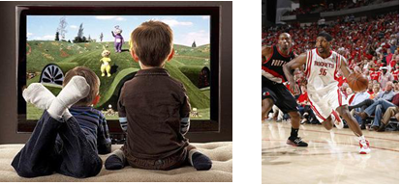

-What’s your favorite program?
1)What do you think of talent shows?
2)What do you think of game shows?
3)What do you think of soccer games?

-After answering the questions, students will pair up and write their partner’s favourite show and explain why their partner likes these shows in no less than 10 sentences.

Language Points(5 minutes):
What do / does sb. think of ...?
How do / does sb. like ...?
love, like, not mind, not like, not stand
E.g.:
—What do you think of soap operas? = How do you like soap operas?
—I don’t mind them.

Activity 1 (20 minutes): Holiday TV Show Plan
-Collect their favourite program essay, pick a random one and answer the questions.
1. What does Mark plan to do later?
2. What does Jack think of talk shows?
3. Does Jack like the news?
4. What does Jack think of talent shows?
5. Does Mark want to watch the soccer game at 5:00? How about Jack?

Answer:
1.He plans to watch TV.
2.He doesn’t mind them, but sometimes they can be a bit boring.
3.Yes, he does.
4.He usually can’t stand them, but the new one is quite funny.
5.Yes, he does. So does Jack.

-Pair work: Practice the conversation. Then make your own conversations.
A: What do you want to watch?
B: What do you think of talk shows?
A: They’re OK. I don’t mind them.
B: Then let’s watch a talk show.

Let some pairs ask and answer about the shows.
A: What do you want to watch?
B: What do you think of sports shows?

-Read the conversation again and match the persons with their favorite shows.
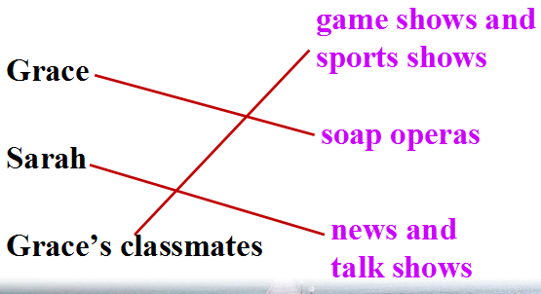

Assessment: Teacher will monitor responses and check answers with students as soon as they finish answering.

Activity 2 (15 minutes): Find someone who...
-Ask your classmates questions and write their names in the chart.
Find someone who … | Students’ names
wants to watch a movie
hopes to watch a sitcom
expects to watch the news
plans to watch a sports show
never wants to watch a game show
-Have different groups come and present their result. The winner will get a box of chocolate.

-Have them read this article and fill in the blanks with several word choices.

My favorite TV program is a reality show called Survivor. It isn’t on TV at the moment 56 it was on last year.
In the show, two teams of people are taken to a (an) 57 . All of them have to sleep 58 because there aren’t any houses or hotels. They usually choose 59 really useful like a toothbrush since they can only 60 one thing with them. The people also have to find food and they spend a lot of time fishing and collecting fruit from the 61 . Every week one person has to 62 . At the end, there are only two people on the island and one them is chose 63 the winter.
I really like Survivor because it’s very 64 and the people have to do things like hunting for food. I really 65 myself when I watch it. I don’t want to be on the show, however, I like living in a house!

take tree beach like island but
leave exciting enjoy outside as something

Answer:

56. but 57. island 58. outside 59. something 60. take
61. trees 62. leave 63. as 64. exciting 65. enjoy

Assessment: Teacher will walk around class and monitor student responses and check if they understand the article.

Closure (20 minutes):
-Review what was learned during these 10 lessons.
-Final Project: Use these sentences and phrases to make a vacation story in class.

What do you think of …?
I like / I don’t like / don’t mind / can’t stand
I think it’s / they’re…
1. plan to do… 2. hope to do…
3. find out … 4. can’t stand …
5. sth. happen 6. expect to do…

